# Question 10: Report

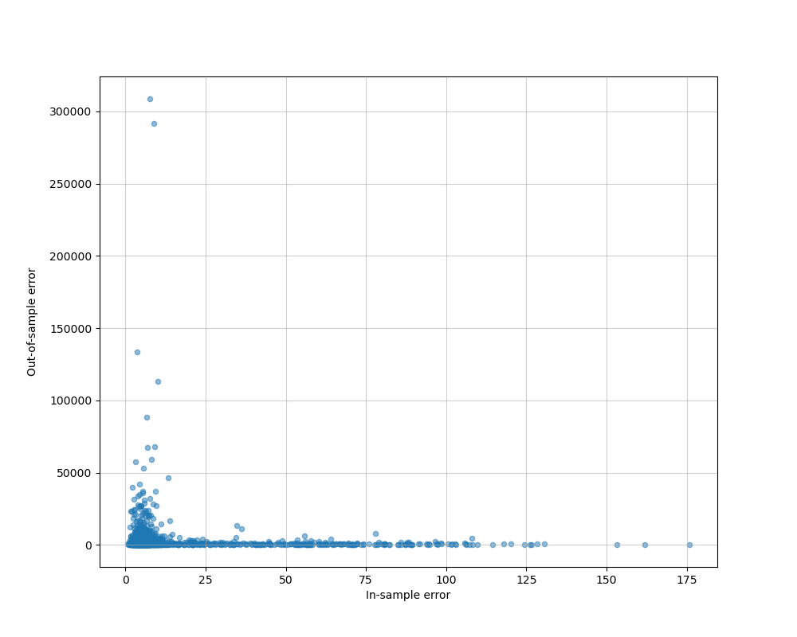

## Explanation:

The first thing we would probably notice is that, there’s 2 points in the upper left corner of the plot, which indicates a small in-sample error, and a relatively large out of sample error. I think this is the result that I would expect, since we only choose 32 from all the 8192 examples, using such a small subset of the dataset would make the model vary greatly, depending on the subset we choose, and if the subset contains outliers, or the examples chosen are not representative enough for the entire dataset, then overfitting to such examples would cause high out of sample error, meaning that the model is nor well generalized. In addition to these 2 points, we can also see that in about 10 experiments, we have out of sample error greater than 50000, which is also quite high. Most of the other points in the lower left corner still shows that the out of sample error is not that small, this result verifies our intuition.

Next, we can see that in the lower middle part, and the lower right corner, there are experiments having nearly 0 out of sample error but higher in sample errors (compared to those having only in sample errors less than 25.) For this part, this result actually matches that in theory, higher in sample error (due to underfitting) would often end up with lower out of sample error, because models like this generalize better than those that overfit. However, I still think that it’s surprising to use 32 points to generalize well on the remaining points, but the amount of experiments like this is small, so I think maybe it’s reasonable due to probability.

Last, observe the whole plot, we can see that the distribution varies a lot over all of the experiments. Even though we don’t know the correlations between the 8192 examples, randomly choosing 32 from them still results in a high variability (since there would be C(8192, 32) possibilities.) As mentioned before, this would cause our distribution to depend highly on the 32 samples we choose, so I don’t think we can tell more by only conducting 1126 experiments.

## Code:

Read in the data:

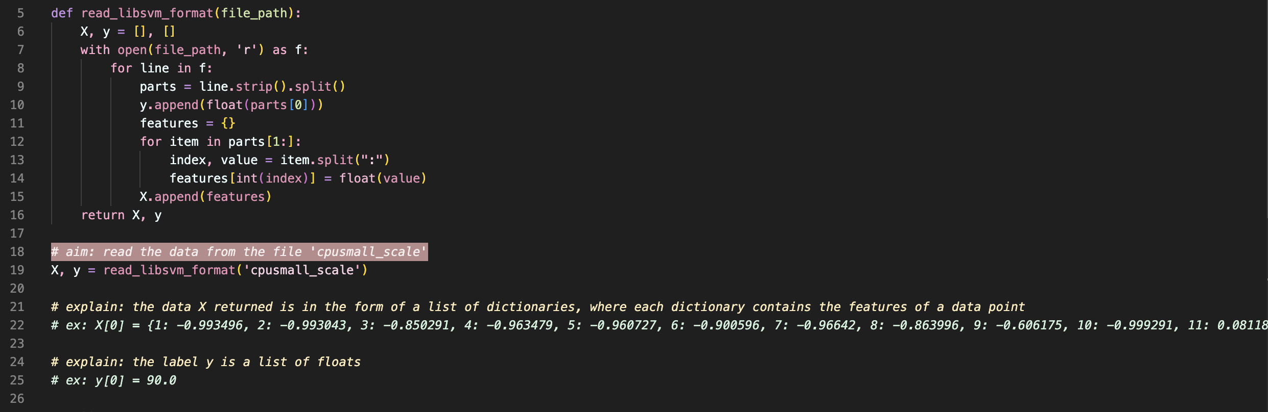

Calculate $w_{LIN}$ and $E_{in}$:

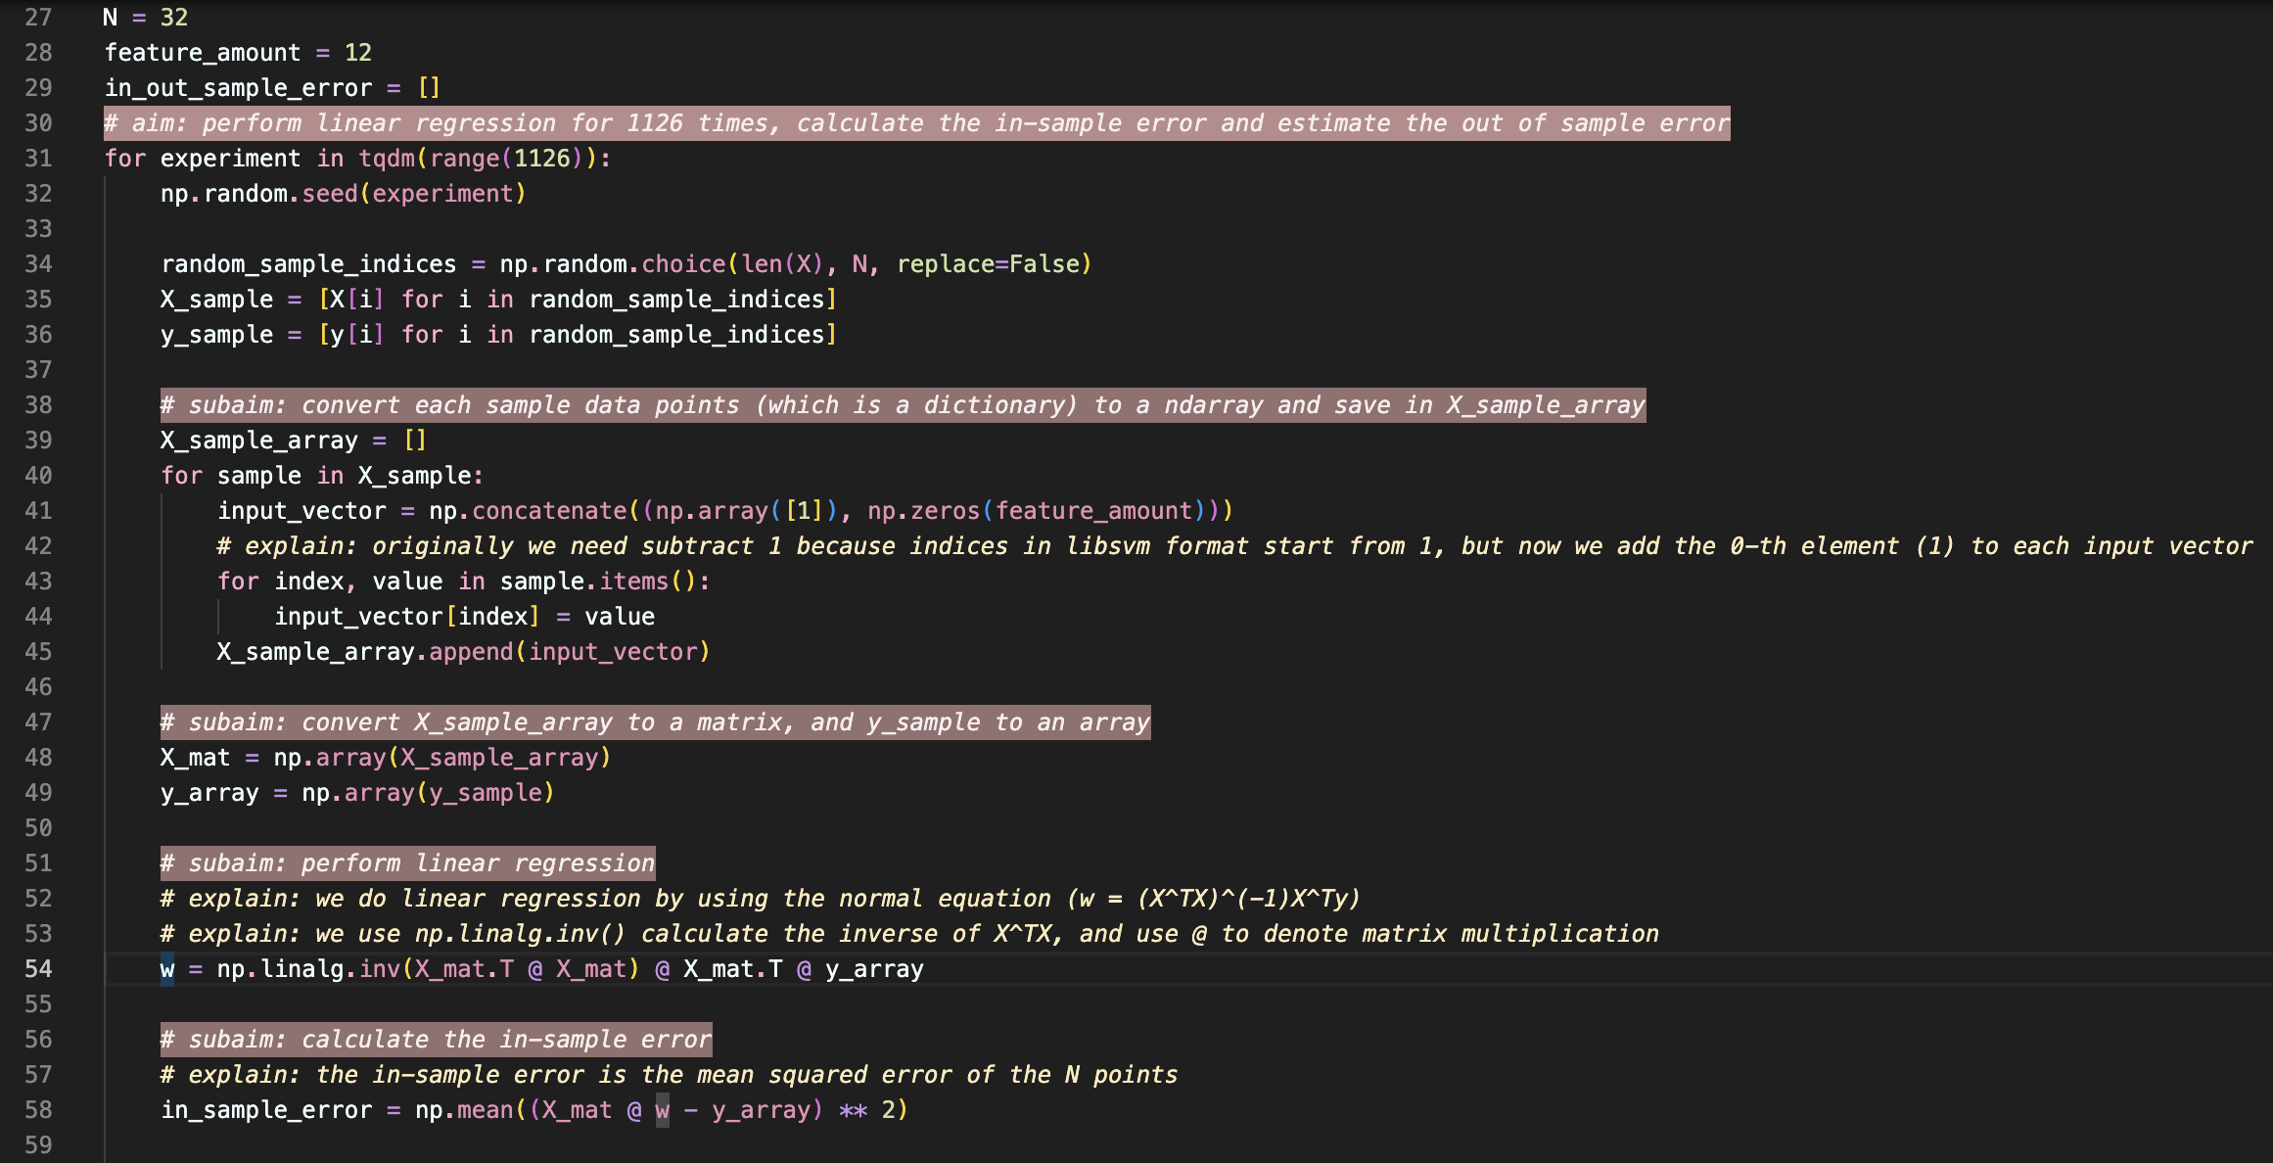

Estimate $E_{out}$:

